Innovation Zone and Annual Conference 2023 Wrap-up

Purpose of Report
For discussion
Is this report confidential? No

Summary
The report provides and overview of the Innovation Zone at the LGA Annual Conference 2023, held in Bournemouth. Innovation Zone pictures are included in Appendix 9A.

LGA Plan Theme: Communications and events

Recommendation

That the Board reflect on the approach, planning and delivery of this year’s Innovation Zone and provide feedback to inform next year’s delivery.

Contact details
Contact officer: Katharine Goodger
Position: Improvement Coordination and Strategy Adviser
Phone no: 07818 562 932
Email: katharine.goodger@local.gov.uk

Innovation Zone and Annual Conference 2023 Wrap-up
Background
- The LGA’s Annual Conference took place on the 4 – 6 July 2023 at the Bournemouth International Centre.
- The Innovation Zone (IZ) is a significant part of the LGA’s Annual Conference and a hugely popular area of the conference. The IZ represents a vibrant and creative space within the wider conference and involved a series of open, walk-in, sessions highlighting exciting ideas within the local government sector.
- All sessions featured in this year’s programme were delivered either by councils themselves, or councils in collaboration with other public sector and private sector organisations.
- This report reflects on the performance of this year’s IZ and the learning to inform future editions.
Approach and Planning
- The IZ was led by a small project team comprising of members of the Improvement Coordination and Strategy team, the Events team and the Communications team.
- Applications for the IZ went live in December 2022, earlier than the previous year, and were open for 10 weeks instead of the previous 4 weeks. This year we received over 200 applications, setting a new record for those bidding to be on the programme.
- LGA officers promoted applications for this year’s IZ across social media, the LGA website, LGA bulletins, first magazine and regional networks to spread awareness, maximise bids from across the public sector, and actively identify innovative ideas and individuals who can take part in the programme.
- Applications were reviewed by members of the project team and internal subject experts to identify the most innovative, impactful, relevant and interesting sessions to schedule. The decision on applications considered the type of council applying, the region of the council, the backgrounds of the speakers, variety in the sessions offered and ensuring representation across political spectrum.
- Given the increased quantity and quality of the applications, having shortlisted and assessed, LGA officers worked over 50 presentation opportunities into this year’s IZ programme.
- The IZ featured three types of session:
  - Parallel IZ sessions which ran across all three stages and featured engaging talks on a range of different approaches and projects. These sessions formed the main content of the programme and covered key council themes such as Adults and Children’s services, climate, communities, economic growth, digital and more.
  - ‘Spotlight on…’ sessions which were more proactively selected based on known significant challenges in the sector and/or opportunities to include excellent speakers with focus on big topics and emerging ideas to inspire and challenge different ways of thinking.
  - Celebrating success events were a new addition to this year’s Innovation Zone. These sessions featured high profile speakers and complimentary refreshments as we brought delegates together to celebrate excellence and achievement across the sector and share information about a range of initiatives.
- The LGA committed to regularly updating IIB members on the IZ’s progress. This occurred through two progress updates delivered to the board in the early stages of planning (December 2022) and towards the end (May 2023). In addition, a Member’s Working Group was implemented to allow for political oversight across the planning process including the approach to content, the space and activity on the day. The working group met three times (March, May and June), feeding into the design, development of the programme, and presentation of sessions on the day.
- The IZ programme was promoted across a range of communications channels including LGA bulletins, social media and press releases including First Magazine.
Delivery of the Innovation Zone
- The IZ featured 3 stands for presentations to take place, as well as a coffee area and seating area. Stands included headphones to minimise noise disruptions when multiple presentations occurred at the same time. Some initial photos of the IZ can be found in Appendix 9A.
- The IZ was opened by Cllr Abi Brown, Chair of the IIB, and Peter Fleming, Chair of the working group. The opening of the IZ and first session featured an overview of the programme ahead and also the 2023/24 sector support programme. The opening culminated with a session from Liverpool City Council speaking about their experience bidding for and hosting Eurovision and the importance of culture.
- LGA officers worked with colleagues in the events team to ensure sessions were planned with reference to the wider conference programme to chart the best times to hold them. Where possible, we attempted to have a variety of sessions occurring simultaneously, so delegates did not have to pick between similar clashing presentations either in the IZ or the wider conference.
- The 5 ‘Spotlight on…’ sessions were promoted proactively and were delivered exclusively of all other activity to ensure they had maximum engagement. Following the success of last year, our Spotlight on Climate Panel was the most popular single session across the 3 days (see Image 6 in Appendix 9A). The talks also included a notable and highly popular presentation from James Kerr, author of Legacy discussing the secrets of success behind some of the world’s elite business, sports and military organisations to the public sector (sponsored by Newton Europe).
- Lead Members of the IIB and those in the Member’s Working Group had an active role in the IZ. Members played a key role introducing Spotlight on talks, launching the IZ and promoting wider IZ activity across the conference. Further details of Board involvement can be found in Appendix 9B.
- The sessions across the 3 days were highly attended with, many timeslots being standing room only (see Appendix 9A). A session time on the Wednesday morning was particularly popular where over 200 people attended across the 3 sessions being delivered.
- Feedback on the IZ has been overwhelmingly positive, gaining recognition as a space and programme which represents a strong draw for delegates to attend the conference. One delegate stated that a single session alone was worth the price of entry to the entire conference. Further positive comments were focused on the energy of the zone, high quality of presentations and learning offered.
Planning and Delivery of the Wider Conference
- In addition to the IZ, the LGA Conference featured a number of improvement informed sessions on the wider conference programmes. In the run up to the event, improvement teams worked jointly with the wider organisation to ensure that improvement considerations are embedded within the wider conference programme.
- A total of 24 parallel sessions took place and 6 parallel plenary sessions across the three days of conference.
- Improvement led sessions held as part of this programme included:
  - A session on sector-led improvement and assurance chaired by Cllr Abi Brown, Chair of the Board, alongside Clive Betts MP, Chair of the Levelling Up, Housing and Communities Committee, Lord Amyas Morse, Interim Chair of the Office for Local Government, and Baroness Taylor of Stevenage OBE.
  - A session on procurement with Cllr Neil Prior, Deputy Chair of the Board, speaking alongside Dr Martin Reeves, Chief Executive of Oxfordshire County Council, and Chaired by Joanne Roney OBE, Chief Executive of Manchester City Council, discussed the leadership role of councils in implementing changes relating to the new Procurement Act.
Reflection points
- Planning will soon begin for the Innovation Zone 2024. To help inform the organisation of this, we welcome your thoughts and feedback on what went well and what could further be improved. This includes views on the following:
  - What do you think worked well about the IZ and can be carried forward? (Planning and delivery)
  - What could have gone better?
  - Any reflections on the role of the IIB in the process?
  - Any thoughts on the wider conference and its programme?
- In addition to the reflections about the IZ already gathered from the conference itself and being discussed by the Board, the LGA Events team have contacted delegates to gather feedback on all aspects of the conference via an online survey which closes/closed on Thursday 20 July 2023. The LGA are also encouraging delegates to email feedback to events@local.gov.uk.
Implications for Wales
- Welsh councils were welcome and encouraged to apply to showcase their ideas at the Innovation Zone and the conference programme was designed to be relevant across the whole of local government.
- The Innovation Zone programme included a session from Pembrokeshire Council as part of its commitment to showcasing new ideas and approaches from across a diverse range of organisations from a variety of backgrounds.

Financial Implications
- All delivery is funded via existing LGA budgets and sponsorship funding.
Equalities implications
- The LGA is committed to increasing diversity at all levels of local government. Officers ensured there were opportunities to include those from underrepresented groups within the conference programme.
- To enable an inclusive environment, councils were encouraged to consider equalities in their bids and sessions to promote a variety of voices in their presentation delivery.
- Additionally, the design of the space reflected on the accessibility needs of all. Headphones were used to allow for sessions to be easily heard, low furniture was utilised, and stages were accessible to wheelchair users. Volunteers in the IZ were briefed to recognise individuals who may need help accessing sessions effectively and to offer support as required.
- To the extent it was possible, officers worked to ensure the programme is representative across all regions, authority types and political affiliations.
Next steps
- Members to discuss the Innovation Zone planning and delivery, and wider conference, to reflect on what went well and where improvement can occur.
- Reflections from the IIB and other stakeholders is being captured. These will be used to inform the process of planning for next year’s Innovation Zone at conference in Harrogate.

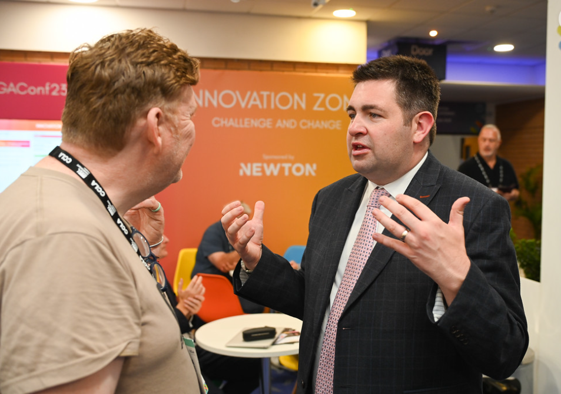
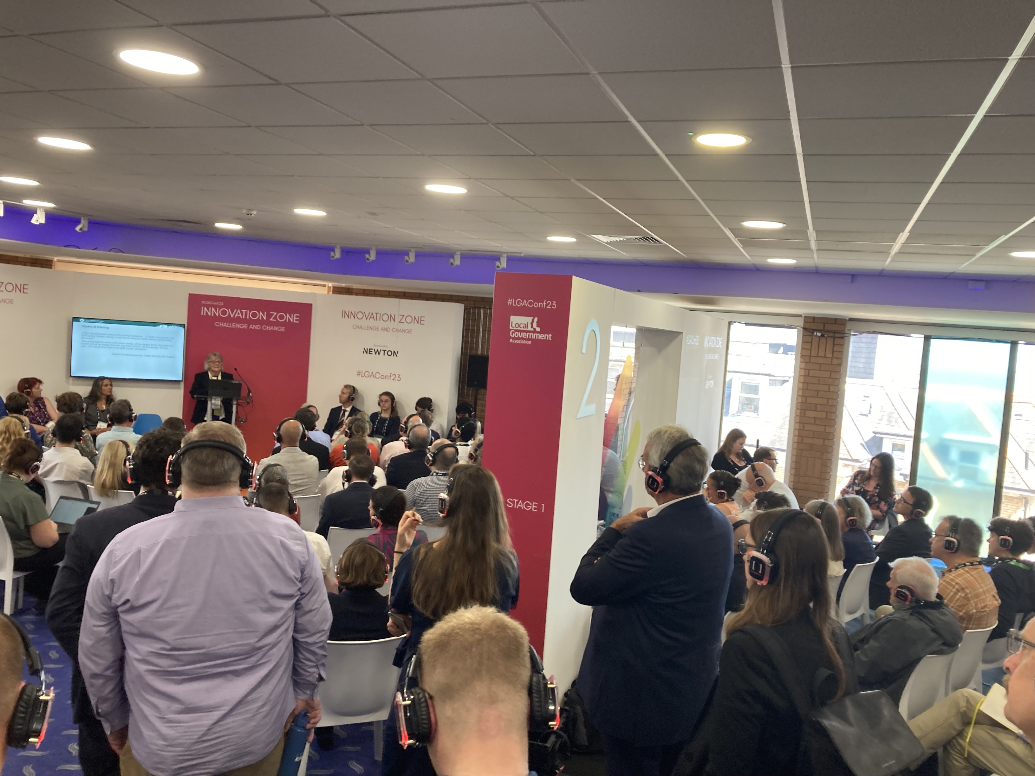
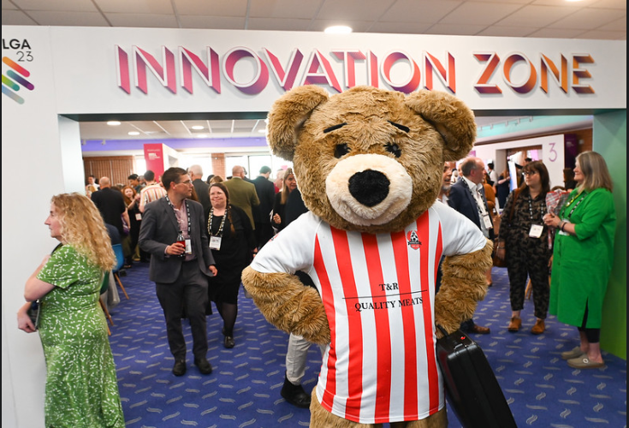
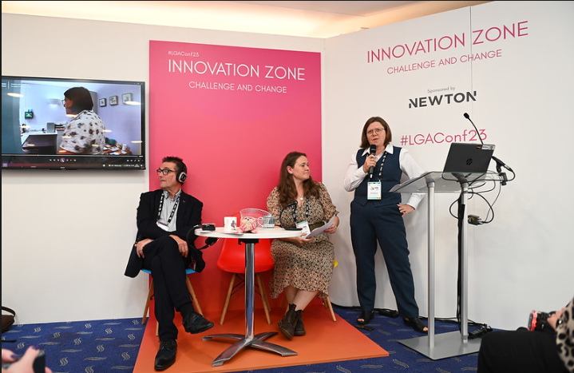
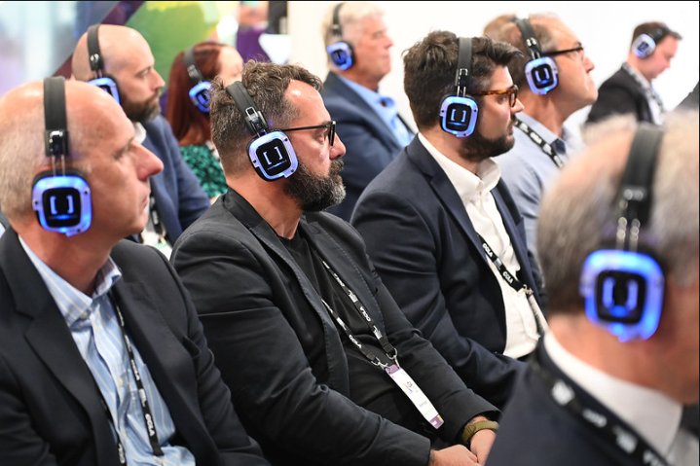
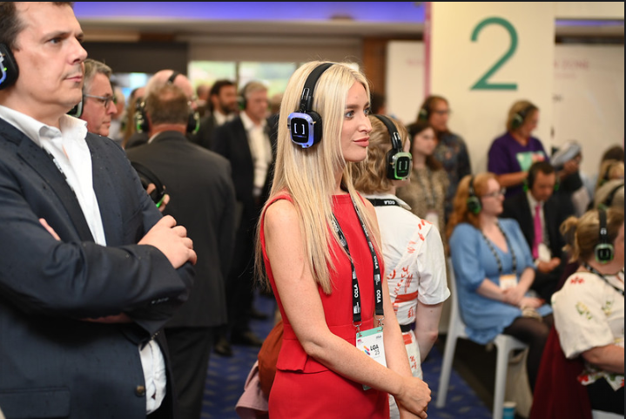
Appendix 9A – Initial Photos of the Innovation Zone 2023
2
3
1
5
46
6
Photo copyright LGA/Gregg Brown Photography

Appendix 9B – Board Member Involvement in the Innovation Zone as part of the LGA Annual Conference 2023

Please note, Members of other LGA Boards were also involved in sessions in the Innovation Zone but are not listed below.
Please note, Members of other LGA Boards were also involved in sessions in the Innovation Zone but are not listed below.
Lead Member | Session Detail
Cllr Abi Brown  (Chair) | Innovation Zone opening session. Eurovision and the importance of culture: in a crowded world, attention needs to be thought about to be won, 11.40 - 12.15pm, 4 July 2023  I, alongside Peter Fleming OBE, Chair of the LGA Innovation Zone Member Working Group, provided the opening address for the Innovation Zone and introduced the opening session for the Innovation Zone at the LGA conference.  Celebrating success… One Public Estate 10-year anniversary, 4.50 – 5.35pm, 4 July 2023  I introduced this ‘celebrating success’ event, honouring OPE’s 10 year anniversary at the LGA conference (Innovation Zone).  Celebrating the work of LGA peers, 12.30 - 1.25pm, 5 July 2023  I introduced this event to celebrate the work of LGA peers and their contribution to the sector’s continuous improvement.
Cllr Brigid Jones  (Deputy Chair) | Spotlight on… All Our Money: Using theatre to engage communities in local authority budget setting, 10.25 – 11am, 5 July 2023  Cllr Brigid Jones, Deputy Chair of the LGA Improvement and Innovation Board introduced this Innovation Zone session mixing live performance with video and discussion to highlight the complexities of budget setting in local authorities and engage communities.
Cllr Liz Green  (Vice Chair) | Spotlight on… Climate Change: Panel session, 3.25 – 4.20pm, 5 July 2023  This panel session on climate change was chaired by Cllr Liz Green, Vice Chair of the LGA Improvement and Innovation Board and featured the Centre for Alternative Technology’s Innovation Labs, Local Partnership’s greenhouse gas emissions calculator and Westminster’s Environmental Justice Index
Cllr Neil Prior*  (Deputy Chair) | Spotlight on… The Strategy Room: A new way to engage the public on net zero, 9.55 – 10.20am, 6 July 2023  Cllr Neil Prior, Deputy Chair of the LGA Improvement and Innovation Board and Cabinet Member for Corporate Improvement and Communities, Pembrokeshire County Council introduced this innovation zone session on tackling the challenge of community engagement on net zero.  In addition, Cllr Neil Prior presented their own session on creating a stronger and more resilient rural community, detailed in point 50 of this paper.
IZ Member-led Working Group | Session Detail
Peter Fleming  (Chair) | Innovation Zone opening session. Eurovision and the importance of culture: in a crowded world, attention needs to be thought about to be won, 11.40 - 12.15pm, 4 July 2023  Alongside myself, Peter Fleming OBE, Chair of the LGA Innovation Zone Member Working Group, provided the opening address for the Innovation Zone and introduced the opening session for the Innovation Zone at the LGA conference.  Celebrating the work of LGA peers, 12.30 - 1.25pm, 5 July 2023  Peter Fleming presented on his experience of being an LGA peer at this event to celebrate the work of LGA peers and their contribution to the sector’s continuous improvement.  Spotlight on… Future Work Design: changing organisation culture one conversation at a time 8.30-9am, 5 July 2023  Peter Fleming introduced this session on an award-winning project established to understand and manage stress risks in local authority settings so that work and organisations can be properly designed to ensure workforce health and sustainability.
Mayor Peter Taylor | Spotlight on… Leadership: the secrets of success behind some of the world’s elite business, sports and military organisations to the public sector, 3.20-4pm, 4 July 2023  Mayor Peter Taylor introduced this session where author James Kerr spoke about the simple secrets of success behind some of the world’s elite business, sports and military organisations and the potential application of this learning in the public sector.  Reimagining Watford – delivering better health and wellbeing outcomes for staff and communities, 10.30-11am, 6 July 2023  Mayor Peter Taylor introduced this session on Watford’s agile mindset which, embedded within their values and principles, has helped staff adopt a mindset that embraces uncertainty and delivers better outcomes for their communities.
Cllr James Hakewill | Modernisation and transformation of a local authority leisure service in Northern Ireland, 4.10-4.40pm, 4 July 2023  Cllr James Hakewill introduced this session where Antrim and Newtownabbey Borough Council presented on the modernisation of the council’s leisure service to meet ambitious corporate objectives and to provide real value to its users.  In addition, Cllr James Hakewill presented their own session on a partnership between the council and the NHS, detailed in point 51 of this paper.
Cllr Victoria Cusworth | Cllr Victoria Cusworth was also a Member of the IZ working Group and provided valuable input into the planning of the IZ, however was unable to attend the conference.
Board Member | IZ Session
Cllr Laura Beddow | Overcoming challenges to digital inclusion in Dorset, 4 July 2023  Cllr Laura Beddow, Member of the Board, spoke in a session on how Dorset Council is taking the lead in rolling out digital inclusion support across the Integrated Care System.

*In addition to being a Lead Member, Cllr Neil Prior was also a Member of the IZ Member-led Working Group.

